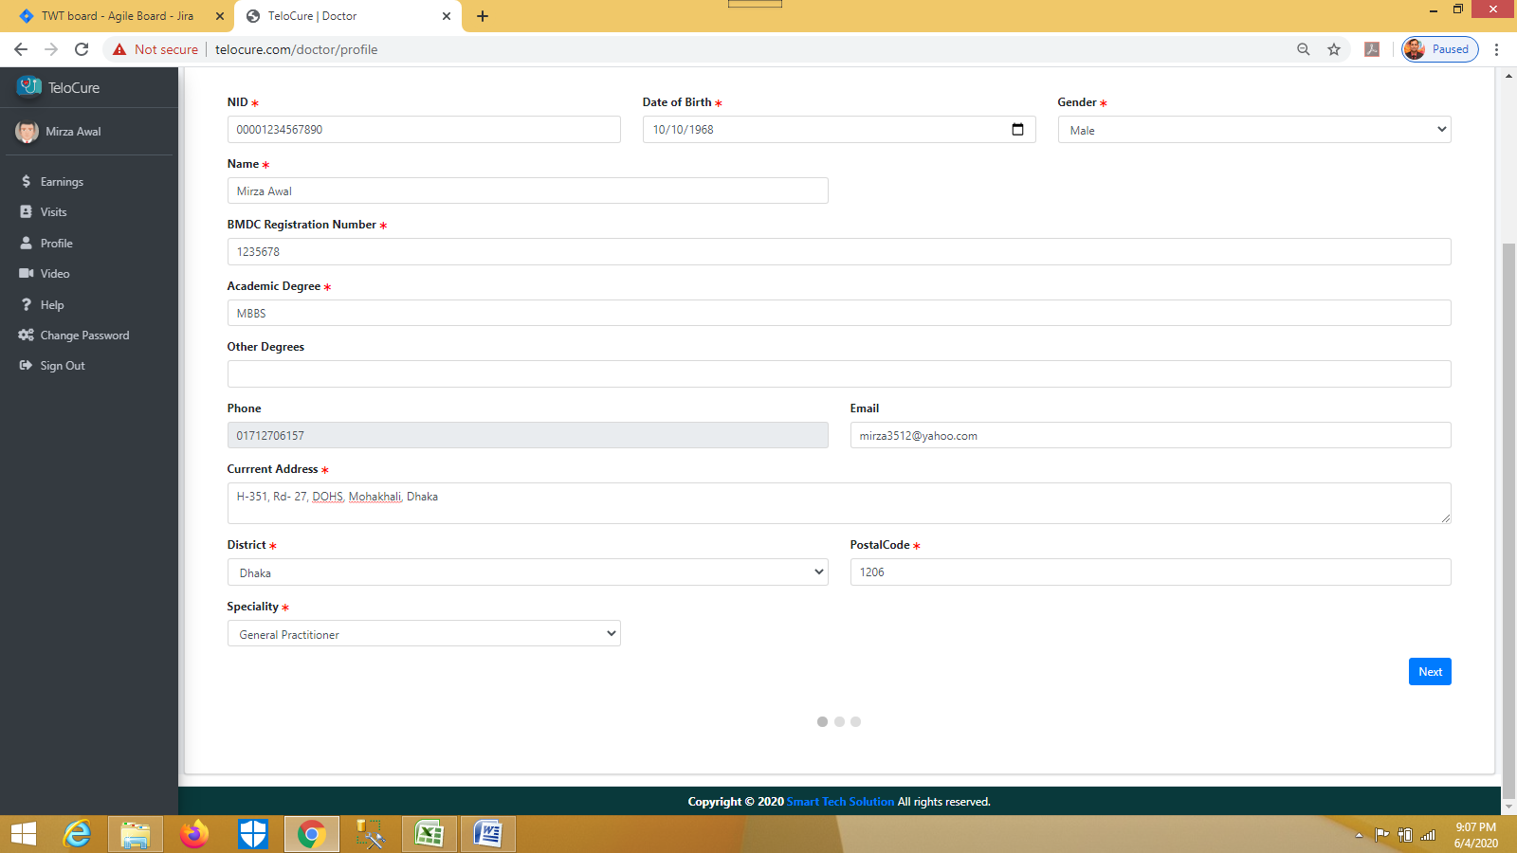Mirza Awal, email - mirza3512@yahoo.com, PW- mirza3512, tel- 01712706157